Doubts regarding Comsol Multiphysics

1. A 3d transient model to understand the effect of combined Buoyancy-Marangoni convection in a cylindrical geometry is presented . In the below model shown in Fig 1, we want to apply the cylindrical coordinates (r, θ, a)



**Fig 1: Schematic of the system**

As a solution to this, we have changed the default cartesian system (x, y,z) to cylindrical coordinates under component< definitons<cylindrical coordinates.

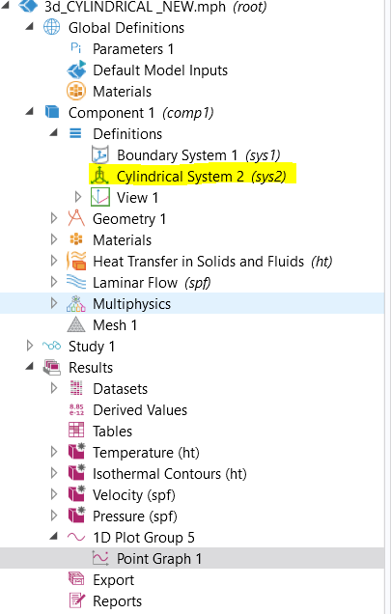

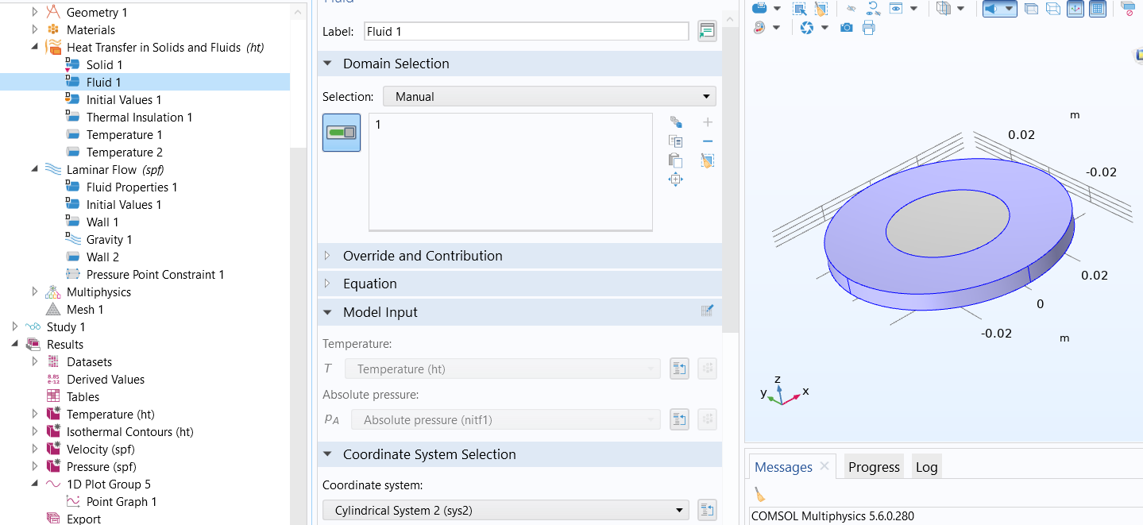

**Fig 2: Applied cylindrical system in the problem**

But while postprocessing we are unable to get the resullts in (r, θ, a) coordinate systems.

Eg: If we want to take the azimuthal velocity ie Vθ, in the drop down only cartisean variables are available ie Vx, Vy, Vz.

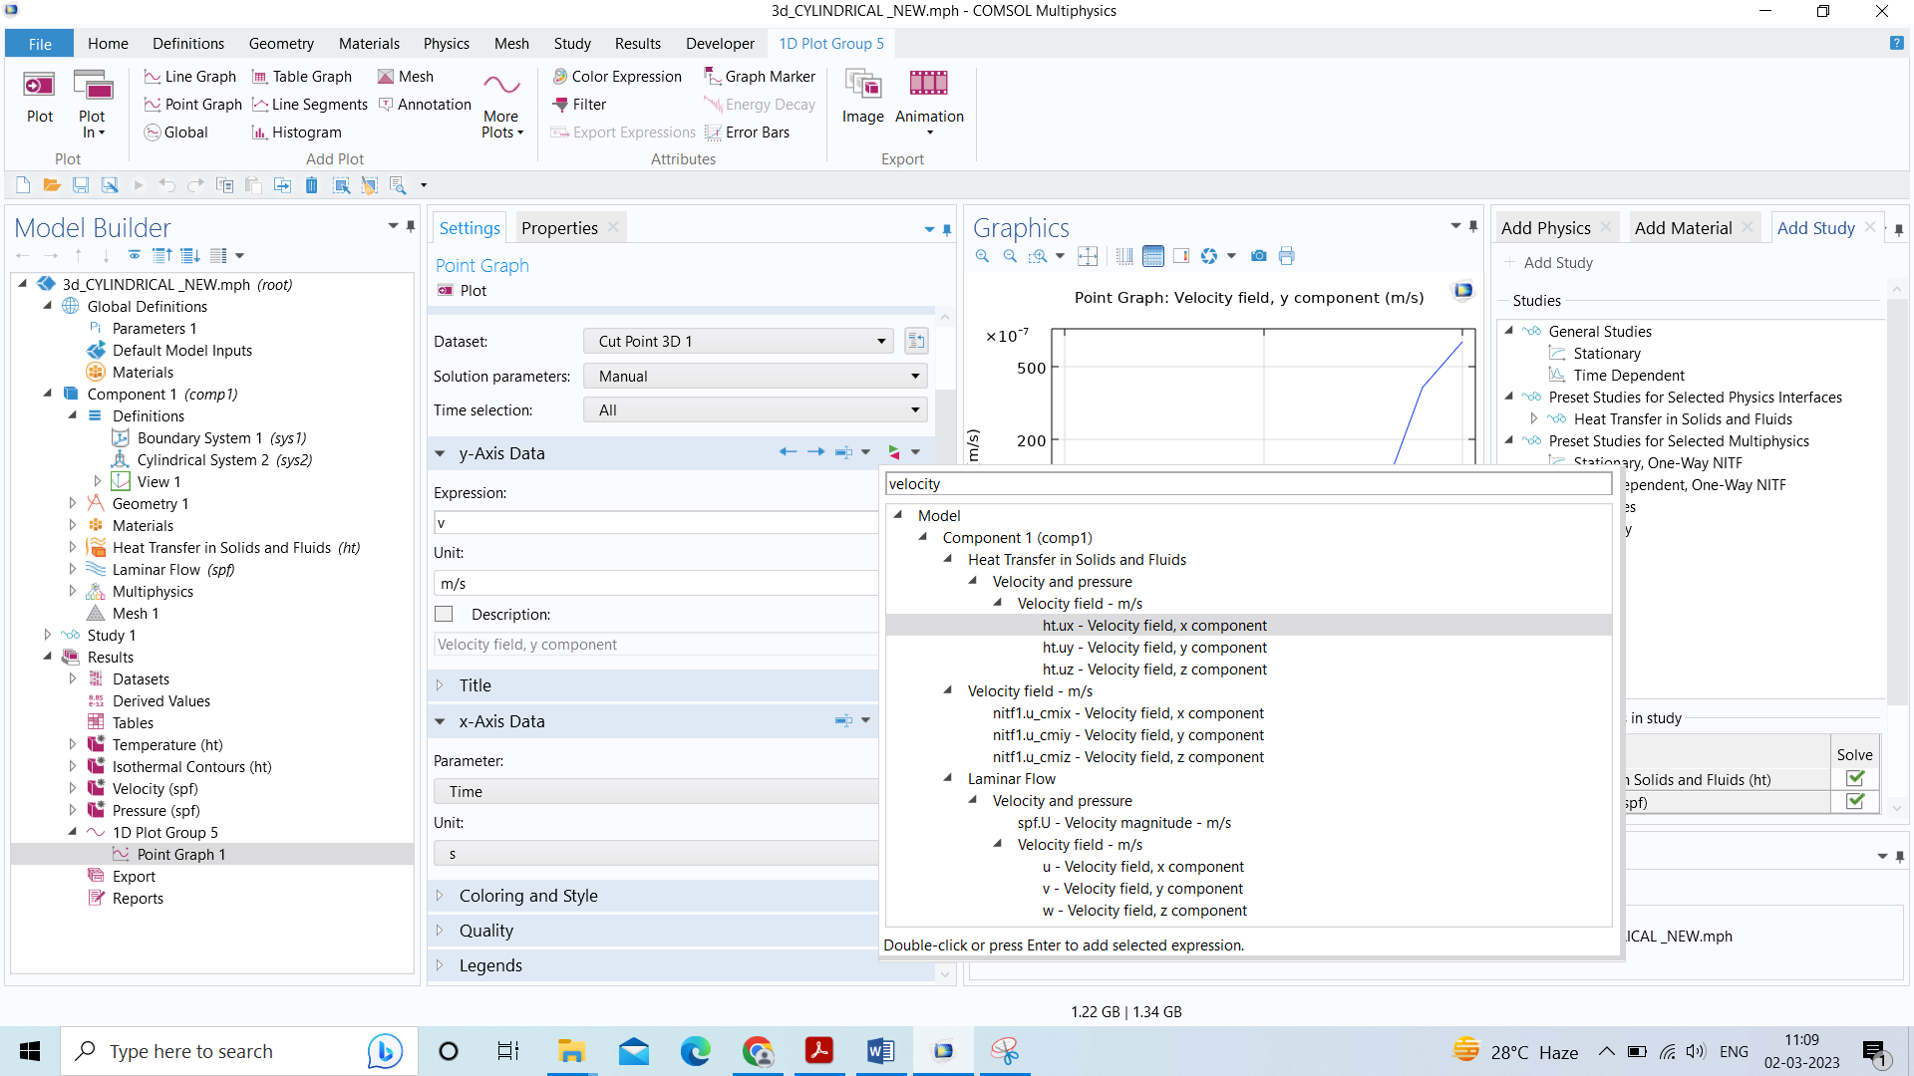

**Fig 3: Post processing with dropdown menu**

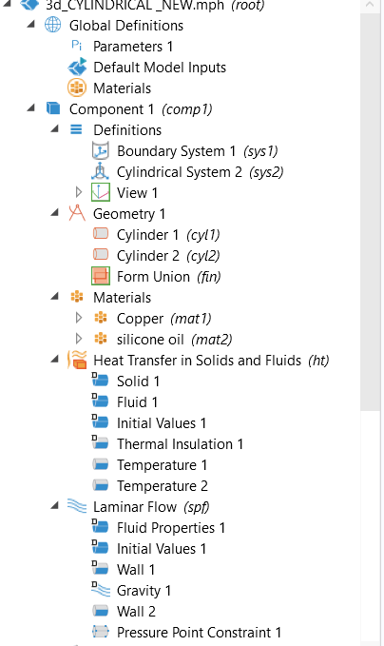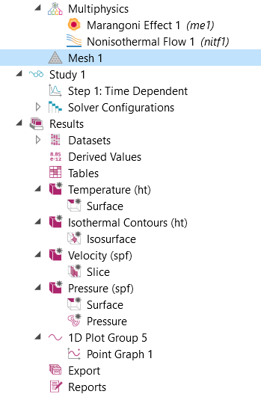

**Fig 4: Expanded tree**

1. We are applying rotation to a similar system and followed the tutorials but the plots are found to be empty. Can you please suggest me where we are doing it wrong?

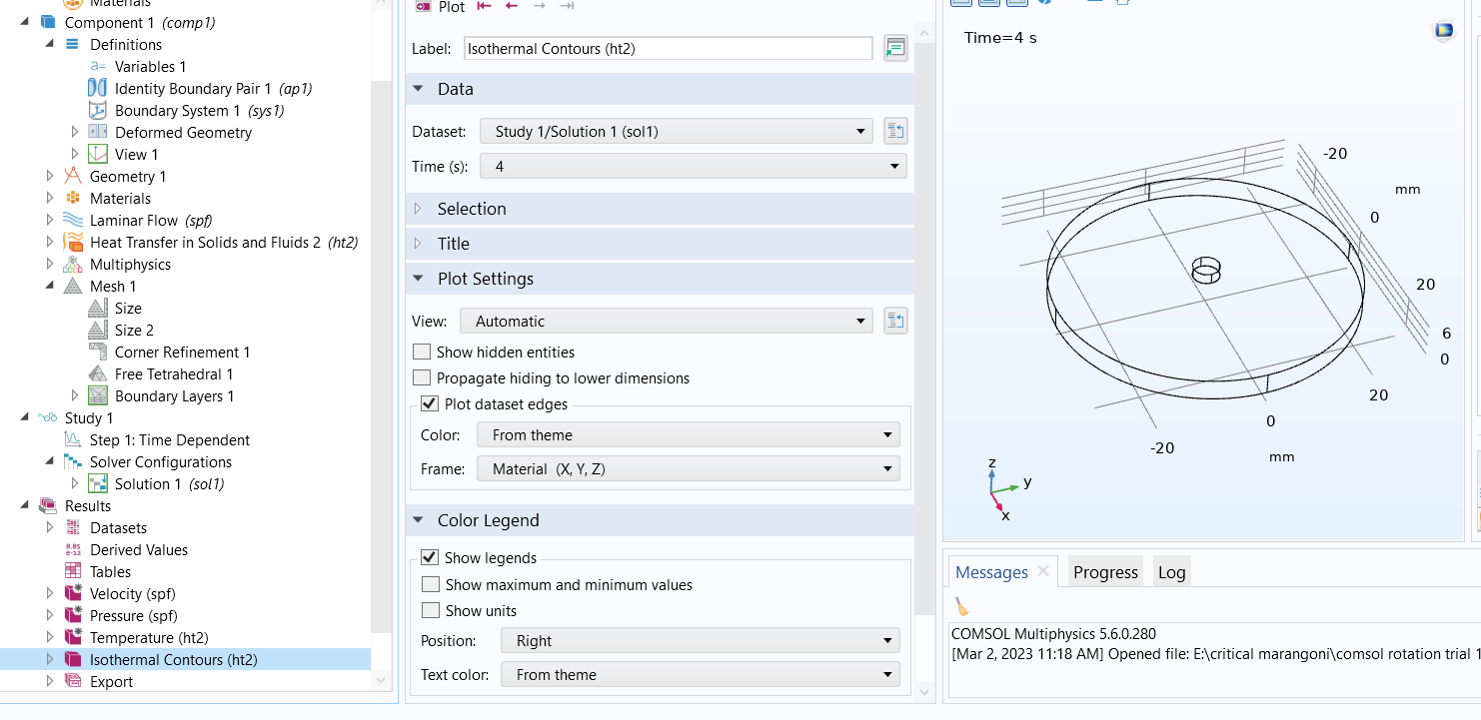

**Fig: 1 Empty plots**

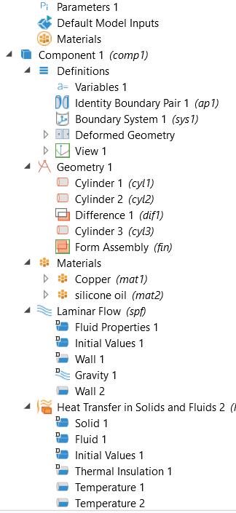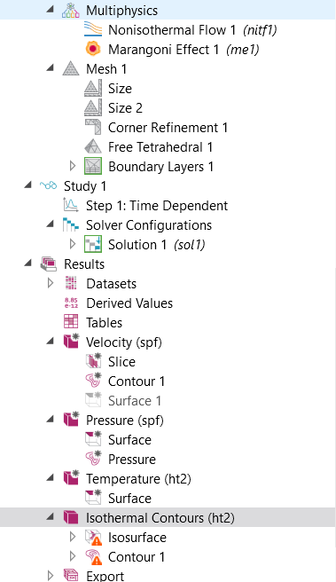

**Fig 2: Expanded tree**