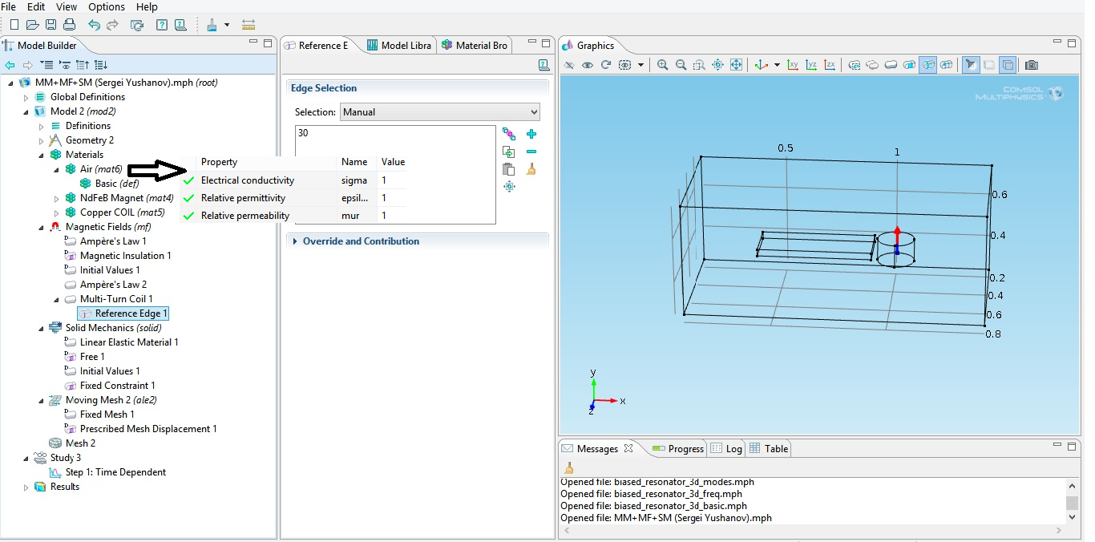
Hy Sir Sergei Yushanov!!
Immense and millions of thanks for so detailed and nice reply of yours. I worked as instructed by you as follows:
- I modified my geometry and coils as u suggested and defined the reference edge as visible in figure above and please you can also view options in the left side which I have used by following your instructions and also used the following parameters of Air medium (kindly check the conductivity, permittivity and permeability values).
I am stuck in last three issues please:
- Do I need to assign Initial values in magnetic field and magnetic insulation (and if insulation required, which portion please) and do I need some other properties to be defined for air?
- Regarding Prescribed Mesh Displacement, should I use (u,v,w) in by default option of Prescribed Mesh Displacement or use another Prescribed Mesh Displacement (Free deformation option will be must in that case)and should I use Sinusoidal function somewhere for sinusoid output like that in Comsol built in model of FREELY Falling Magnet voltage induction (30[mm]*Sin(2*pi*f0*t)) and if I have a particular feasible frequency value obtained from Modal Analysis of cantilever beam, where is that frequency value to be used?
- Finally I am unable to apply Maxwell’s stress tensor forces as instructed by you and cannot find that option in Structural Mechanics interface and hence cannot couple Magnetic and Solid Mechanics interface and just can have Body Load option for applying force.
Kindly help me in solving these last issues, it will be yours big favor for me.
Regards with best wishes please and if possible can u email me at m.farman134@yahoo.com and send me your brief info because you are the first one who is giving me the start and it will be an honor for me to include your name in the authors list in the near future (in 2 to 4 months) and ever first publication because it is just based upon your help.

