Method 1: pzd.Y11
Method 2: this circuit simulation to calculate piezoelectric impedance.
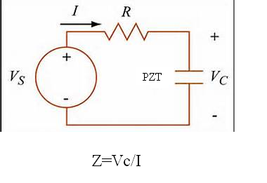
Results:
Method 1:

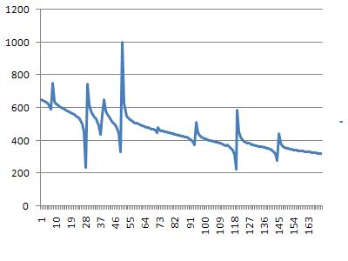

Method 2:

