Hi, everyone,

I have built a geometry using “rectangle” and a “interpolation curve” (which is new function in Geometry node of the new V 4.2a). The original source in the “interpolation curve” is a file (a series of x-y positions obtained from COMSOL using “export”), and then I import all the data into the software into a “Table”. The plotted interpolation curve with the name of “ic1” is illustrated in Fig.1.

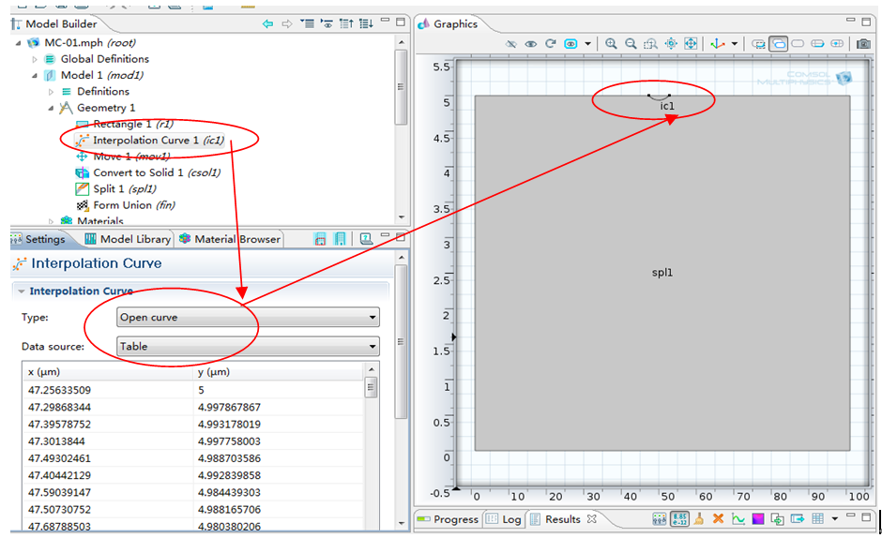§
Fig. 1 Details in interpolation curve

The software COMSOL can automatically recognize the “interpolation curve”. As the Fig. 2 (in the material node) and Fig. 3 (in the physics node) shown. The original domain is divided into two domains at a first glance.

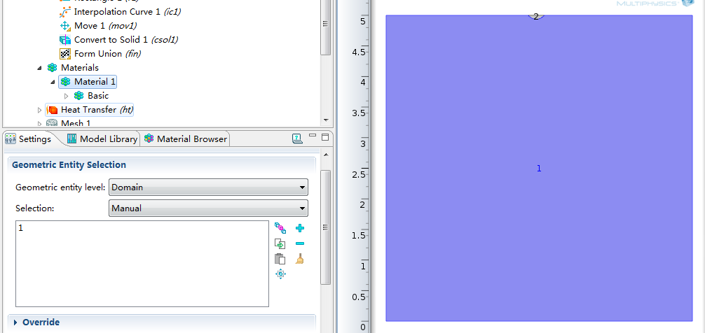
Fig. 2 The sub-domains (1 & 2) in the material domain node

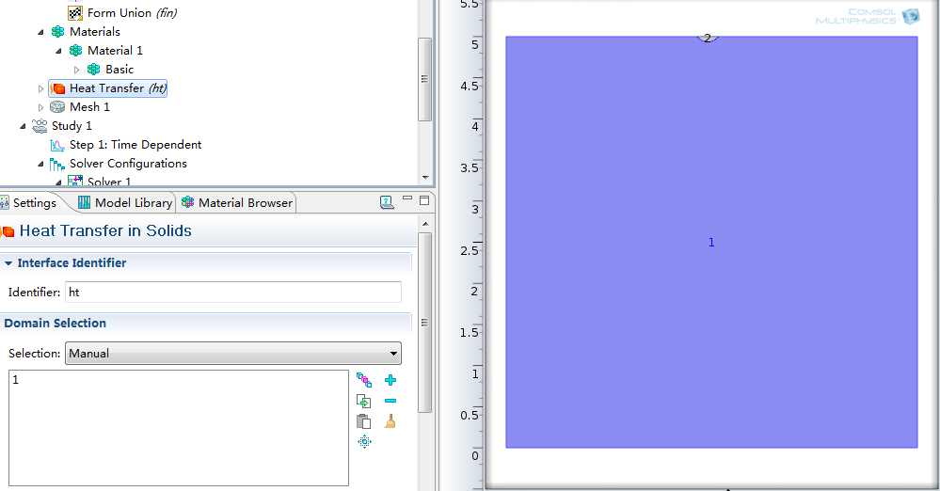
Fig. 1 The sub-domains (1 & 2) in the physics domain node

While when I solve it, the following error occurs (shown in Fig. 4):
“
Failed to insert point.
-x-coordinate: 47.7932
-y-coordinate: 4.97622
An invalid cavity was detected.
Error in multiphysics compilation.
-Feature: Compile Equations: Time Dependent(sol1/st1)
-Error: An invalid cavity was detected.
“
Firstly, I didn’t know its meaning. I searched the error in the forum with the help of finding the reason and solution. Then I look at the mesh node, the above-mentioned error are also shown in the mesh node (just shown in Fig. 4).

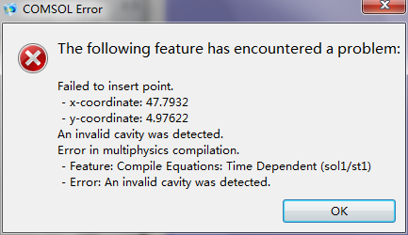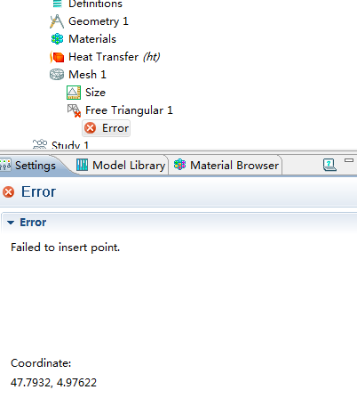
Error when solving
Error at the mesh node
Fig. 4 The error in the study and mesh node

Could anyone mind checking and giving me some suggest and help?

Thanks sincerely in advance for your response.
Best wishes to you and your family.
Yours
FM Huang
Dec.27th.2011

