Hi, everyone,

Recently, I have created a geometry using the “interpolation curve” (new functionality in 4.2a), but there are some problem puzzle me a lot. Could you do me a favor to give me some help and suggest? Thanks.

Original data and scatter plot
The data for the interpolation curve is obtained from the contour in the “Result”--> export into a file (.txt). All the original data are shown in the .txt file and unordered (I don’t why the extracted data is unordered). I plot all the data in other software using scatter plot, just shown in the Fig. 1.

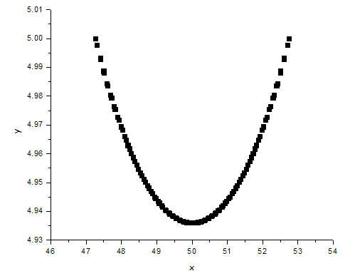§
Fig. 1 Scatter plot of the original data

Using the unordered data
Firstly, I used the above original data to as the input of the “interpolation curve”, while there is something wrong. When I mesh the domain, the “fail to insert point” error occurs just as Fig. 2 illustrated.

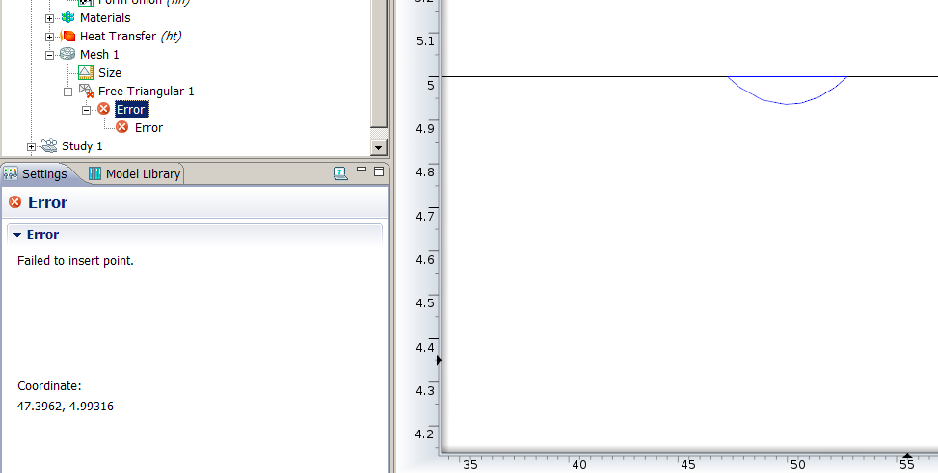
Fig. 2 The error when mesh
Then, I plot the point (47.3962, 4.99316) with the name of pt1 (the above error says where fail to insert point), just shown in the Fig. 3.
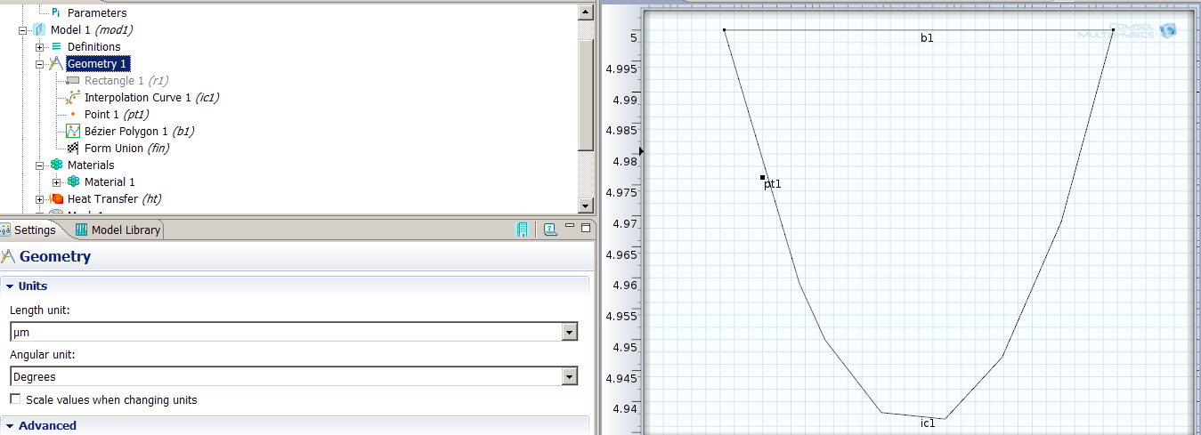
Fig. 1 The error point, interpolation curve and a line in the Geometry node

There is no obvious error in the geometry in the Geometry node, and the geometry is similar to the plot in Fig.1. However, when I turn to the material and physic nodes, the original geometry are quite different and baffling, just shown in the Fig. 4 and Fig. 5.
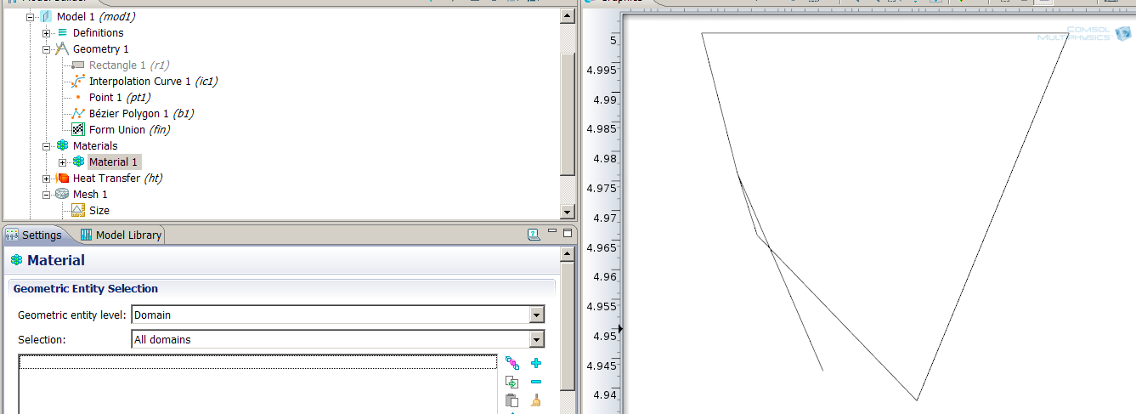
Fig. 4 The geometry in Material node
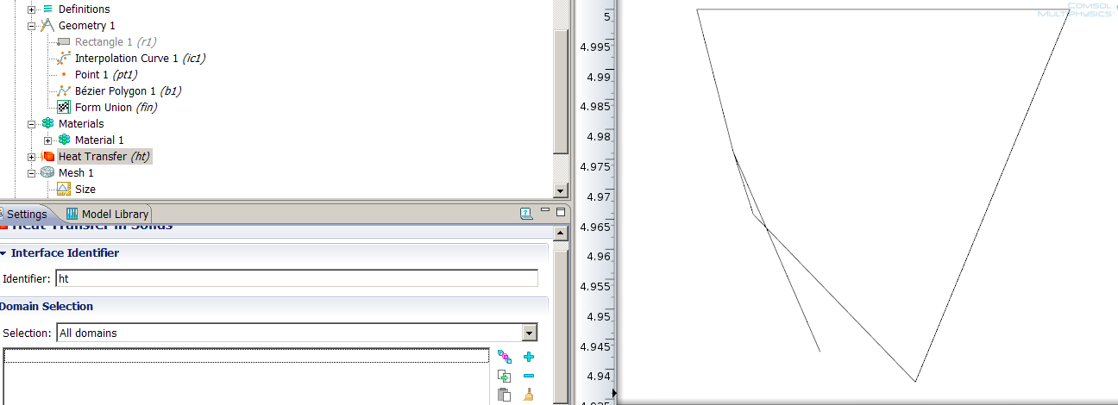
Fig. 5 The geometry in the Physics node

I am quite puzzled with the different geometry in the different nodes (Material node, Material node and the physics node). Why is there such difference? If there is a difference between different nodes, does it mean it is necessary to check the geometry in the Material or Physics node after creating the geometry in the Geometry node?

Using the ordered data
I have handled the data into x directional ascending order, and then use the “interpolation curve” to create the geometry. The Fig. 6, Fig. 7 and Fig. 8 show the geometry using closed curve, solid curve and open curve (type of the interpolation curve).

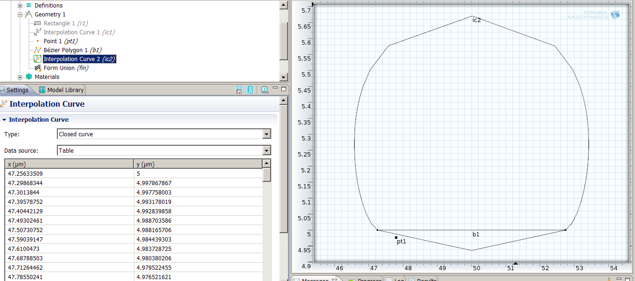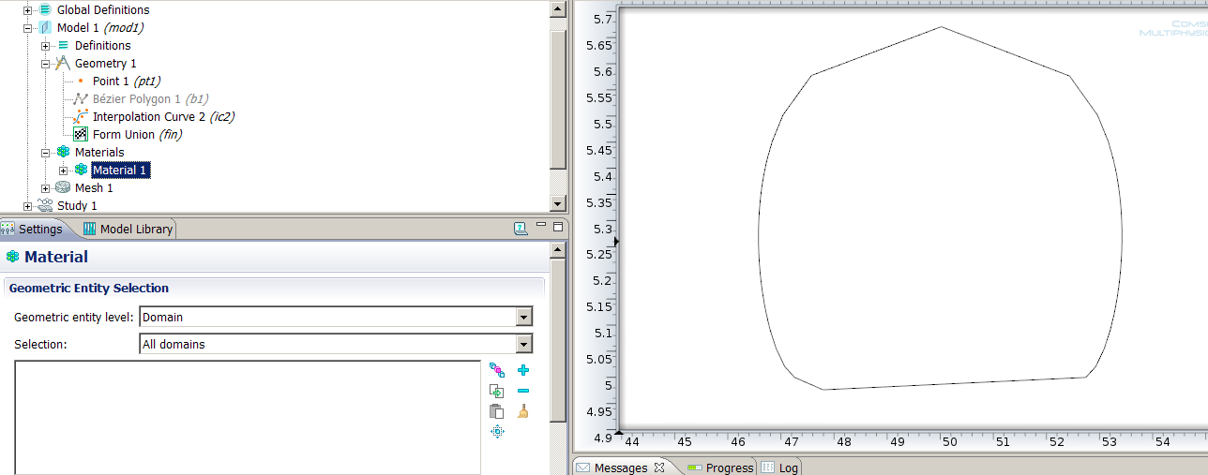
Fig. 6 Closed interpolation curve
In the Geometry node
In the Material node
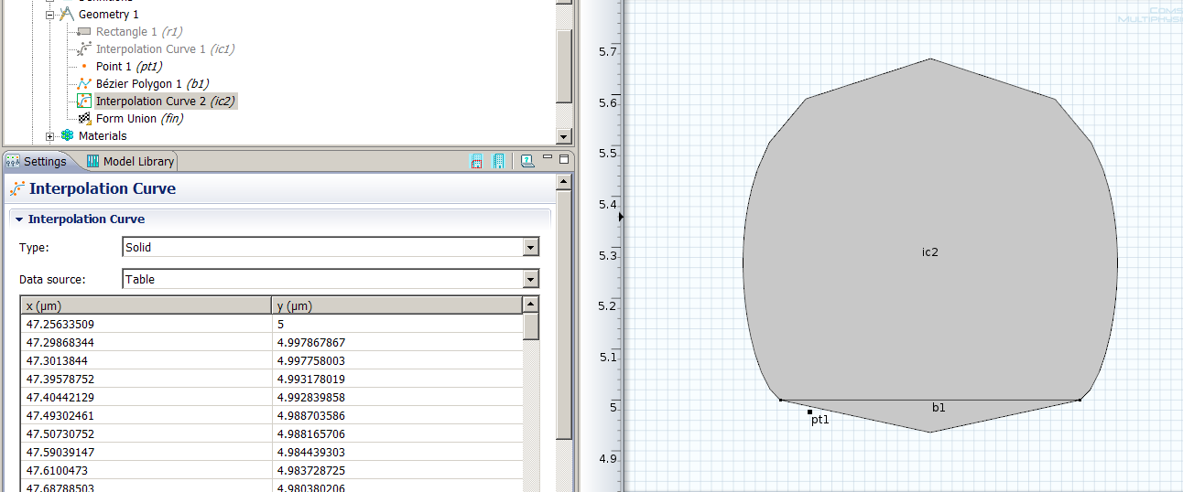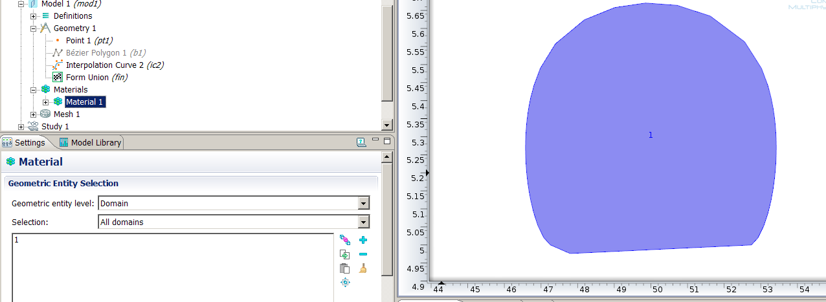
Fig. 7 Solid interpolation curve
In the Geometry node
In the Material node

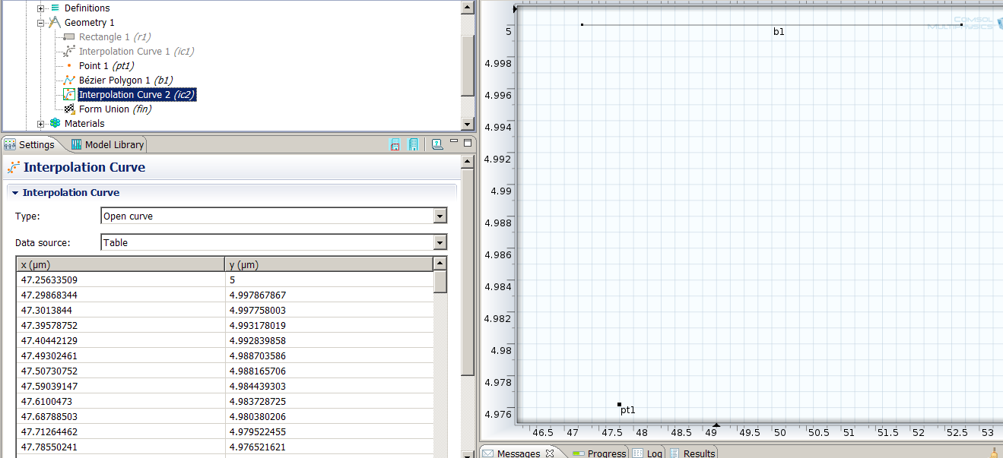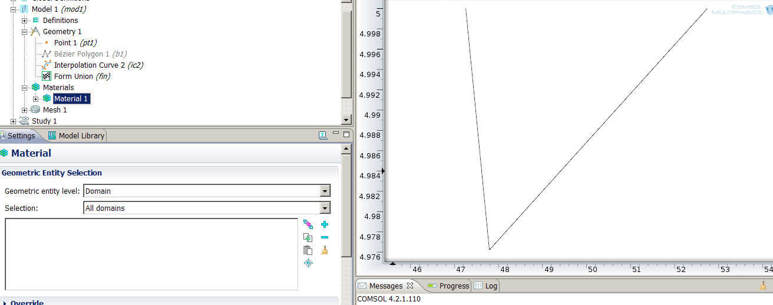
Fig. 8 Open interpolation curve
In the Geometry node
In the Material node

As we can see from Fig. 6 ~ 8, the both curve are different the input data. Furthermore, the geometry in the Geometry node and the Material node are quite different.

The theoretical plot using interpolation curve should be similar to the Fig. 1. Do I misunderstand the new functionality interpolation curve? What and how can I do to plot a line using such kind of data?

Thanks sincerely in advance for your help.
Best wishes to you and your family.

Yours
FM Huang
Jan.3rd.2012

