COMSOL, Inc.  100 District Avenue  Burlington, MA 01803 USA  Phone: +1 781-273-3322  Web: www.comsol.com  Blog: www.comsol.com/blogs | Media Contact:  Natalia Switala, PR & Communications Manager  natalia@comsol.com  Image Gallery:  www.comsol.com/press/gallery

COMSOL Releases Version 5.4 and Introduces Two New Products

The latest version of COMSOL Multiphysics® features COMSOL Compiler™, giving specialists the freedom to distribute their simulation applications through executable files, and the Composite Materials Module for layered structures analysis.

BURLINGTON, MA (October 3, 2018) — COMSOL today announces the latest version of COMSOL Multiphysics Version 5.4, which in addition to two new products provides performance improvements and additional modeling tools.
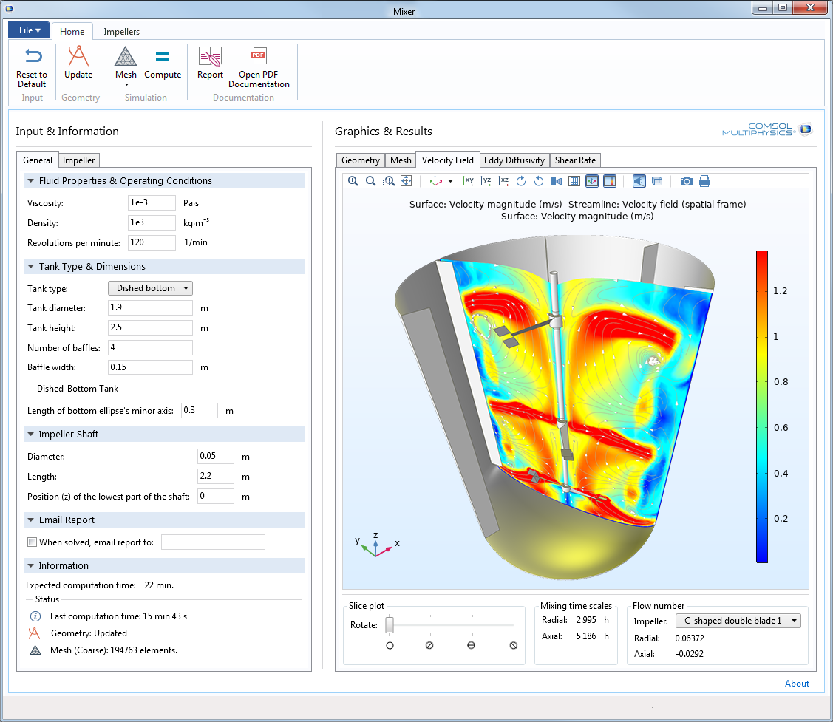
New COMSOL Compiler™
COMSOL Compiler allows you to create standalone COMSOL Multiphysics applications. Compiled applications are bundled with COMSOL Runtime™ – no COMSOL Multiphysics or COMSOL Server™ license required to run. You can distribute such applications with no further license fees. “Specialists can create simulation applications with the Application Builder that we released a few years ago. This has provided a new way for teams of engineers and scientists to bring the use of simulation to non-specialists. A little later we released COMSOL Server which is used to deploy and administrate applications via a web interface. With COMSOL Compiler we are taking things to the next level by letting specialists compile an application into a single executable file for unlimited use and distribution. This is a level of freedom that the industry has not seen before”, said Svante Littmarck, President and CEO, COMSOL.
An example of a compiled simulation application where users can optimize a mixer.

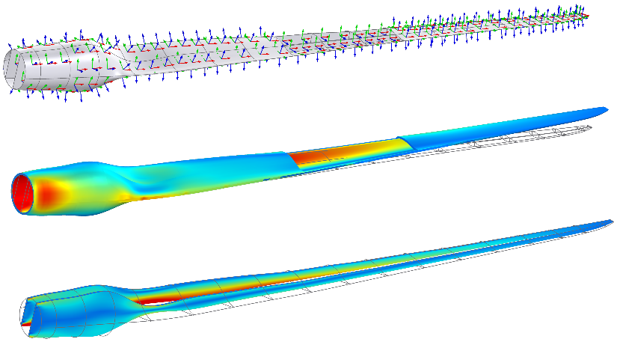
New Composite Materials Module
“The Composite Materials Module delivers modeling tools for users working with layered materials”, said Pawan Soami, Technical Product Manager at COMSOL. “Composite laminated structures could have more than a hundred layers and setting up such a simulation is cumbersome without dedicated tools. We now offer such tools”, continues Soami.

By combining the Composite Materials Module with new functionality for layered shells available in the Heat Transfer Module and the AC/DC Module, users can perform multiphysics analysis such as Joule heating with thermal expansion. “The ability to couple structural mechanics analysis in layered shells with heat transfer and electromagnetics, provides users with unique multiphysics modeling capabilities”, says Nicolas Huc, Technical Product Manager at COMSOL. An important application of multiphysics analysis in laminated materials is managing the impact of lightning strikes on wings and wind turbine blades within aerospace and wind power industries.
Wind turbine blade. From top to bottom: Visualization of the shell local coordinate system, and von Mises stress in skin and spars respectively.

Enhancements to COMSOL Multiphysics and add-on products
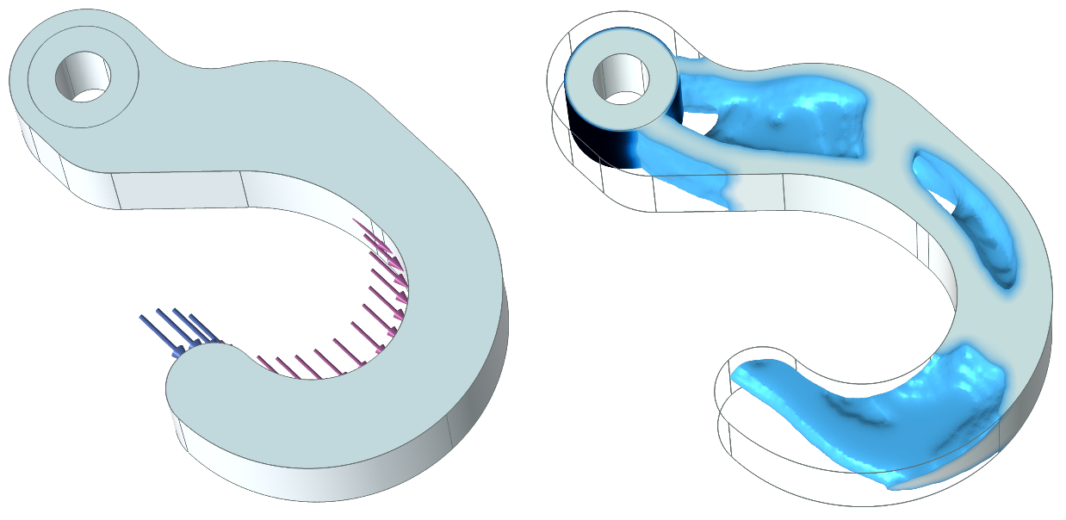
COMSOL Multiphysics version 5.4 comes with numerous productivity improvements such as the ability to use multiple parameter sets in a model, including parametric sweeping over multiple parameter sets. Furthermore, users can now organize the Model Builder nodes into groups and assign custom coloring schemes to geometry models.

Among the various performance improvements is the updated memory allocation scheme that gives several times faster computations in the Windows® 7 and 10 operating systems for computers with more than 8 processor cores.

The AC/DC Module features a new part library with fully parametric and ready-to-use coils and magnetic cores. The CFD Module comes with large eddy simulations (LES) and significantly updated modeling tools for multiphase flow.
Topology optimization of a hook. The simulation finds the optimal material distribution when the structural part is subjected to two load cases.

Highlights in version 5.4
- COMSOL Compiler: For creating standalone executable applications.
- Composite Materials Module: For modeling layered materials.
- COMSOL Multiphysics: Multiple parameter nodes in the Model Builder. Group Model Builder nodes into folders. Coloring of physics and geometry selections. Several times faster solution time in the Windows® 7 and 10 operating systems for computers with more than 8 processor cores.
- Multiphysics: Heat transfer, electric currents, and Joule heating in thin layered structures.
- Electromagnetics: Fully parametric and ready-to-use parts for coils and magnetic cores. Structural-thermal-optical-performance (STOP) analysis for ray optics.
- Structural: Shock response spectrum analysis. Material activation for additive manufacturing.
- Acoustics: Acoustic ports. Nonlinear acoustics Westervelt model.
- Fluid flow: Large eddy simulation (LES). Fluid-structure interaction (FSI) for multiphase flow and multibody dynamics.
- Heat transfer: Heat radiation with diffuse-specular reflections and semi-transparent surfaces. Light-diffusion equation.
- Chemical: Lumped models for batteries. Updated thermodynamics interface.
- Optimization: New topology optimization tool.

Availability
COMSOL Multiphysics, COMSOL Server, and COMSOL Compiler software products are supported on the following operating systems: Windows®, Linux®, and macOS. The Application Builder tool is supported in the Windows® operating system.

To browse version 5.4 release highlights, visit www.comsol.com/release/5.4.

To download the latest version, visit www.comsol.com/product-download.

About COMSOL
COMSOL is a global provider of simulation software for product design and research to technical enterprises, research labs, and universities. Its COMSOL Multiphysics® product is an integrated software environment for creating physics-based models and simulation applications. A particular strength is its ability to account for coupled or multiphysics phenomena. Add-on products expand the simulation platform for electromagnetics, structural, acoustics, fluid flow, heat transfer, and chemical applications. Interfacing tools enable the integration of COMSOL Multiphysics® simulations with all major technical computing and CAD tools on the CAE market. Simulation experts rely on COMSOL Server™ to deploy applications to their design teams, manufacturing departments, test laboratories, and customers throughout the world. Founded in 1986, COMSOL has 19 offices worldwide and extends its reach with a network of distributors.
~
COMSOL, COMSOL Multiphysics, LiveLink, COMSOL Compiler, COMSOL Runtime, and COMSOL Server are either registered trademarks or trademarks of COMSOL AB. For other trademark ownership, see www.comsol.com/trademarks.

